Diagnostics Beeper
Requirements Specification

ITW Weigh Wrap
401 W Market St.
Troy, OH 45374
9/27/2018

APPROVAL CHECKLIST

Function | Lead | Approval Date
Business Unit Manager
Engineering | Scott Davis
Finance | Jeff Johnson
Marketing | Cherie Buhler
Manufacturing | Teresa Williams
Sourcing | Graham Nurse
Quality | Debra Dyer
Global Supplier Development | Rodrigo Flores
Product Integration | James Meyer
Service | David Fosnight

VERSION HISTORY

Version  # | Implemented  By | Revision  Date | Approved  By | Approval  Date | Reason
1.0 | Scott Davis | 9/27/2018 |  |  | Initial version

Overview
The HT Series Scale and Next Generation Wrapper (NGW) have various support needs that require operator intervention. Both devices have the capability to communicate wirelessly to other network computing devices but lack the ability to communicate directly to retail grocer fresh department employees (supervisors and support personnel) in real-time. Enabling these employees with a low-cost Diagnostic Beeper (DB) that they can carry with them within the fresh department for which a scale or NGW can communicate with provides a new level of real-time support for a variety of daily grocer operations.
A feasibility analysis has been performed to determine the effectiveness of this approach as well as prototypes developed demonstrating the technology. See Figure 1. This specification identifies the requirements of an HFL BLE implementation in the HT Series Scale and the NGW.
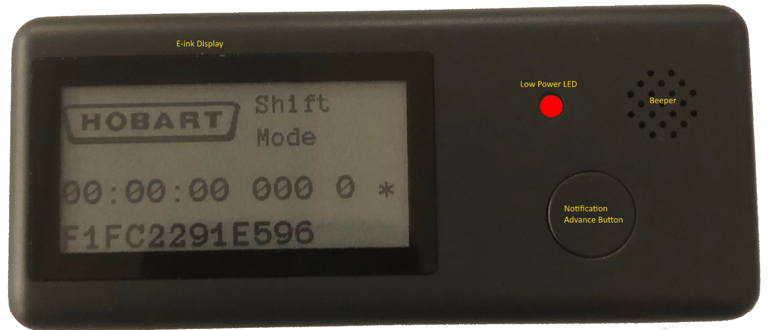
Figure 1. Diagnostic Beeper Prototype

Requirements
The Diagnostics Beeper (DB) shall be a minimal footprint device with a persistent display that can wirelessly communicate with an HT Series scale or NGW. The wireless technology employed shall be Bluetooth Low Energy (BLE). BLE technology is already built-in to the HT Series Scale and the NGW.
The scale shall transmit notifications and diagnostics about HT series scales and NGW units within a 20-meter range (Line of Sight up to 60 meters) in a typical non-line of sight environment.
The DB shall alert (beeping sound or vibration) and display queued notifications (any ASCII character text up to 32 characters and two lines of thee display) with timestamp that the user needs to be aware of such as but not limited to:
- Scale or NGW out of label stock (beneficial for a scale or unattended self-service scale to notify an operator in the department to replace label stock)
- NGW out of film and needs replaced
- Scale out of level warning (HT plus required accelerometer for out of level detection)
- Scale printhead issue (HT plus required resistance levels indicate damaged head)
- Scale or NGW network connectivity status (off or on-line)
- Scale or NGW product and pricing information updated
- Scale or NGW diagnostic error code information to be used for service or support
- Inter-department messages from scale operators requiring assistance from individuals with DBs
- Scale queue from the queuing management system is large and assistance is needed to help customers
- HTe Business/Enterprise or customer help desk originated messages destined for holders of DBs
The DB shall have a persistent display (such as e-ink technology) so the last notification displayed by the beeper is displayed even when the unit is powered down.
The DB shall make a beeping sound or vibrate when a new notification is received. The DB shall provide a button to advance thru pending notifications to be read.
The DB shall be able to store up to 100 notifications before the oldest notification is removed.
The DB shall be designed to operate for 6 months (8 hours per day in a 7-day week) without the power source being replaced. The DB shall have a method to replace the power source (batteries) when required. A red LED shall flash when the power source is at 10% of maximum capacity.
The DB shall be designed so that the dimensions are less than 4-inch length x 1.75-inch width x 1 inch deep.
The DB shall have a data plate with the Hobart logo, model and serial number, and Bluetooth MAC address.

Implementation Logic
The DB shall provide the following implementation in software to perform all its required features.
Customer data info and FIFO message queue shall be stored in flash memory, so the data is nonvolatile and available when power is cycled.
Entire display shall be able to be updated. This shall include initial customer data info and when button first pressed after power on the next FIFO flash message in queue displayed with time stamp.
When the DB is powered on the customer data info in the DB flash memory is displayed on entire display screen. The customer data info in flash memory is customer logo image and/or text which is configurable via BLE message and Bluetooth MAC Address of the beeper.
The display format shall be as follows:
- Line 1 - Customer Logo
- Line 2 - Number of FIFO flash message alerts in Queue and battery status.
- Line 3 - Beeper Bluetooth device MAC address
The first DB button press after the beeper is powered on and the customer data in flash memory is displayed shall display BLE messages in FIFO flash message queue one after the other in chronological order received as the DB button is pressed.
When a new BLE message is received it is placed in the DB flash memory FIFO flash message queue, not necessarily displayed, so that the user can read the queued messages one after the other by depressing the button on the DB
DB shall make a sound when a new BLE message alert is received in FIFO flash message queue. The BLE message is NOT necessarily displayed at that time. Just indicates to user there is yet another message pending to be read in FIFO flash message queue
Button on DB when depressed advances to the next BLE message received in the FIFO flash message queue and shall display and implement the following logic:
- Line 1 is Time of BLE message received in FIFO flash message queue that is currently displayed and the number of messages still pending in FIFO flash message queue to be read as well as status.
Example Display Format on Line 1:
HH:MM:SS [LAST OCTET OF TX DEVICE IP ADDRESS][NUMBER MSGS] [STATUS]
where time stamp of message is displayed HH = hours, MM = Minutes, SS = Seconds, Transmitter Device IP address, and [NUMBER MSGS] = number of messages in FIFO flash message queue that have not been displayed on DB screen and read by user. [STATUS] is the status of the DB:
Character 1:
! = Battery Voltage Level Low, change batteries
* = Battery Voltage Level OK
Character 2:
> = BLE message overflow, messages have been lost due to operator not reading them
< = BLE messages in message queue and queue has not overflown
- Line 2- N. Contents of the text of the next message received in the FIFO flash message queue. If number of characters in FIFO flash message queue to display is over maximum that can be displayed on lines 2-N truncate text and place “...” at end of message when displayed. Maximum number of characters that will fit on these lines.
Once a message in the FIFO flash message queue is displayed pressing the button on DB advances to display the next BLE message and the message that was displayed is deleted from the FIFO flash message queue.
Power off device after N minutes, configurable via BLE message, to save battery life.
Programmable beeper software logic program via USB port and BLE message download
A software programmer’s Application Programmer’s Interface (API) shall be provided documenting the above programming information and interface.

